**CS 340 README Final**

**About the Web Application Dashboard CRUD**

This project allows an authorized user to access a database with existing data about animals at a shelter. It allows authorized users to initiate CRUD (create, read, update, delete) functions within the expected database. With these functions, This dashboard will display the data requested.

**Motivation**

This project was developed as an interactive dashboard for the client, Grazioso Salvare, which allows employees and authorized users to maintain and serve the needs of the animal rescue.

**Getting Started**

Starting this project, PyMongo is needed as well as having a current version of Python installed on the device. MongoDB must also be installed and run a database connection.

1. Enter the MongoDB shell using the terminal
2. Import the required CSV file (aac_shelter_outcomes.csv)
3. Authenticate User and Access Python/Run Program

**Installation**

MongoDB (https://www.mongodb.com/docs/manual/installation/)

PyMongo (in mongo: “pip install pymongo”)

Python (https://www.python.org/downloads/)

Dashboard .ipnyb file

Jupyter Notebook

**Usage**

Code Examples:

This Python library has classes for CRUD operations in a database collection. It includes the methods to create and read documents from the DB collection.

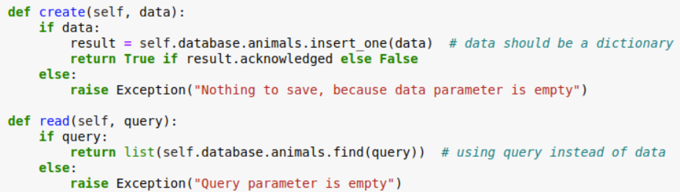

Methods to update and delete data from documents in the DB collection.

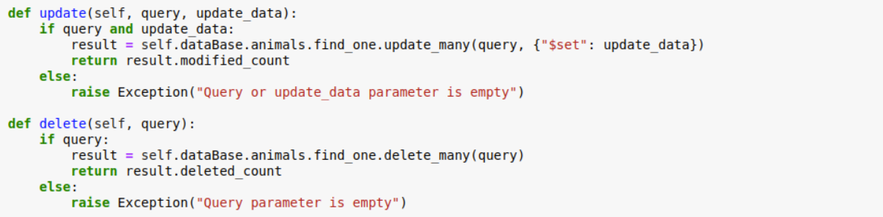

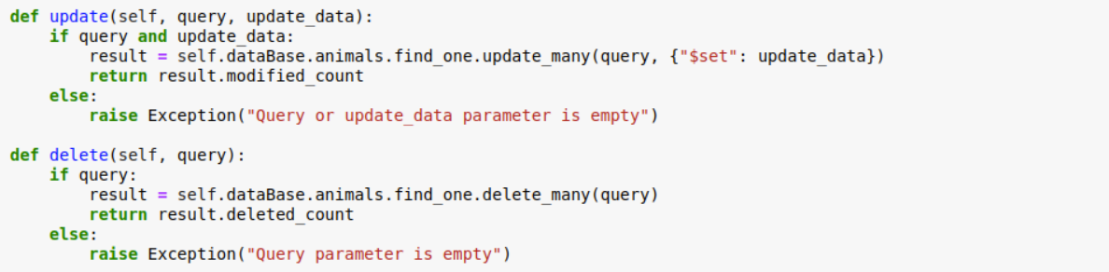

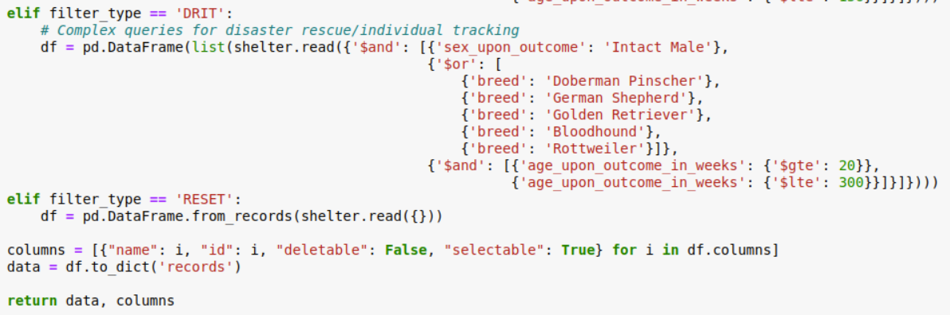

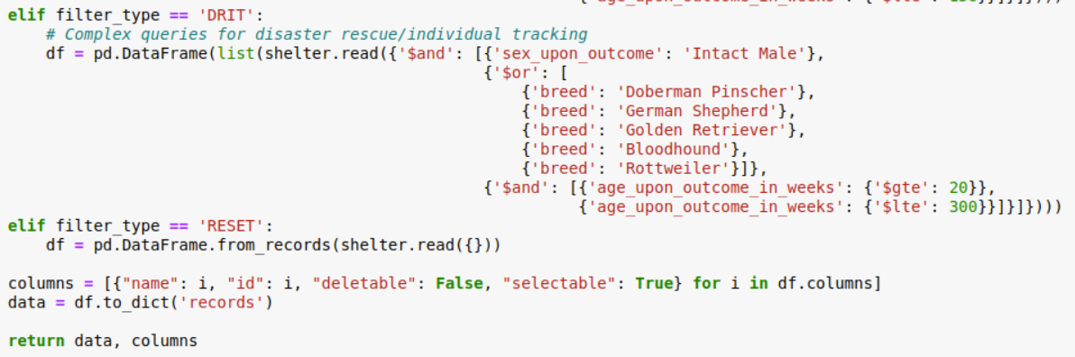

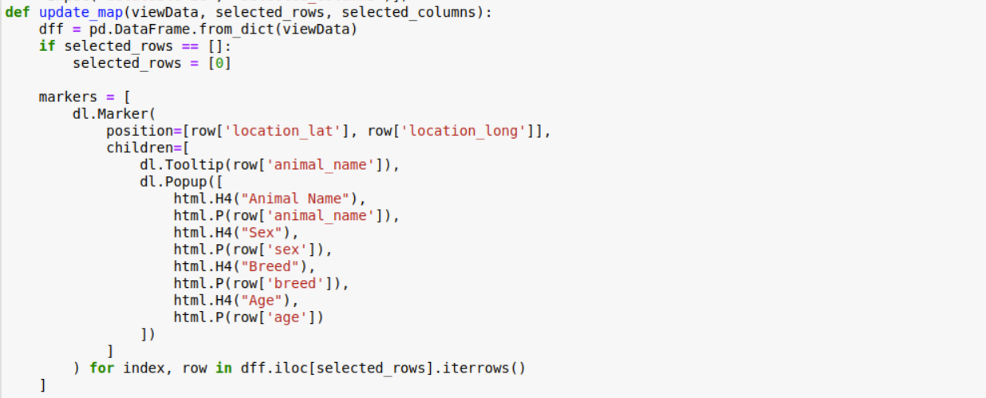

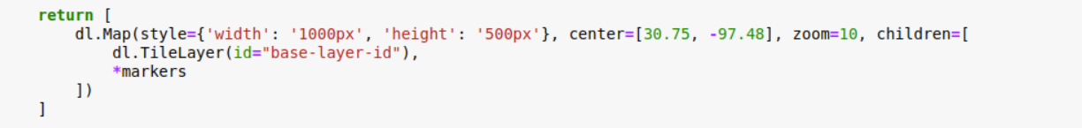

**Tests**

Imports the AnimalShelter class from module. Instantiate the object of the AnimalShelter class. Tests the create method by adding a document into MongoDB collection. Tests the read method by querying documents from the MongoDB collection.

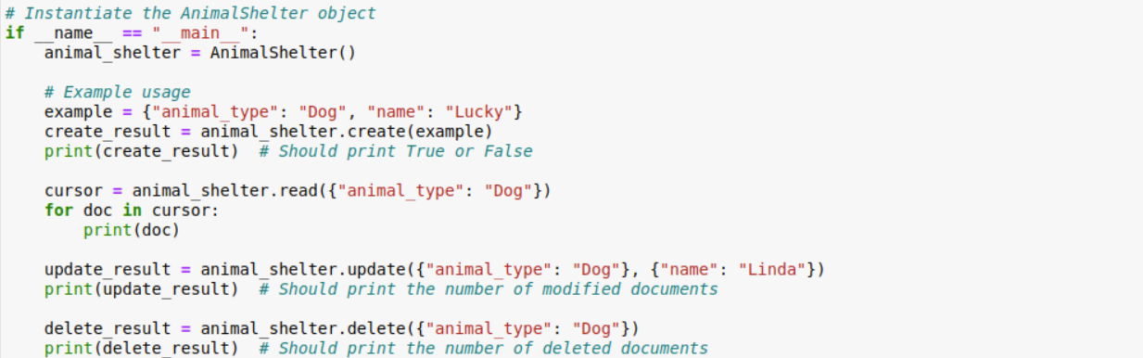

**Contact**

Jamie Javis – jamie.javis@snhu.edu